**How To Use Tableau?**

You just need to follow the below 3-step mantra to use Tableau:

1. Connect to data
2. Play around with the UI(User Interface)
3. Create visualizations

**1. Connect to data**

The first thing to do in Tableau is to connect to your data. There are mainly two types of connections-

Connecting to your local file or connecting to a server.

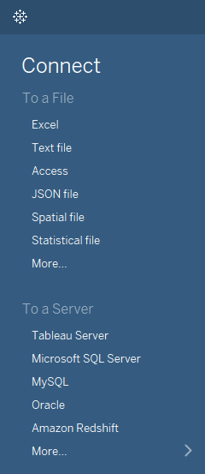

Tableau can connect to any local file or database such as-

* Excel
* Text File
* Access
* Statistical File, or
* Other Database file.

Local connection gives the maximum speed of data processing.

Tableau can connect to your data server too. It can connect to almost any type of data server. Below are some of the most popular databases that Tableau can connect:

* Tableau Server
* Google Analytics
* Google BigQuery
* Hortonworks Hadoop Hive
* MapR Hadoop Hive
* IBM DB2
* IBM BigInsights
* IBM Netezza
* Microsoft SQL Server
* Microsoft Analysis Services
* Oracle
* Oracle Essbase
* MySQL
* PostgreSQL
* SAP

While working on Tableau, data can have Live Connection where any change in the source data will be automatically updated in Tableau. On the other hand, data can be Extracted to Tableau repository so that any change made here will not affect the original source data.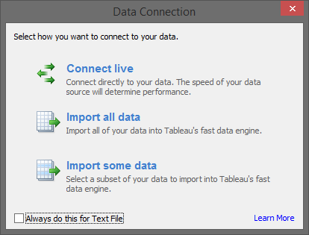

**Data Joins**

You can also integrate different data-sets together to link up and produce better insights. There are different ways to join data-sets. Refer to the diagram below to understand them all.

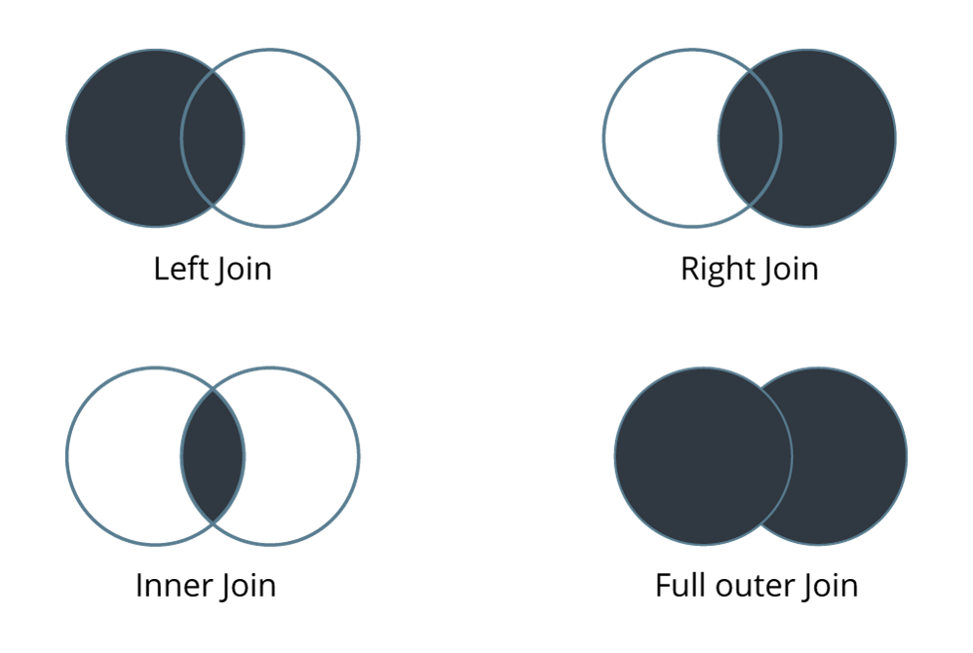

In the above diagram shows the four data-set join options available in Tableau.

**2. Play around with the UI**

This is how the user interface looks like:

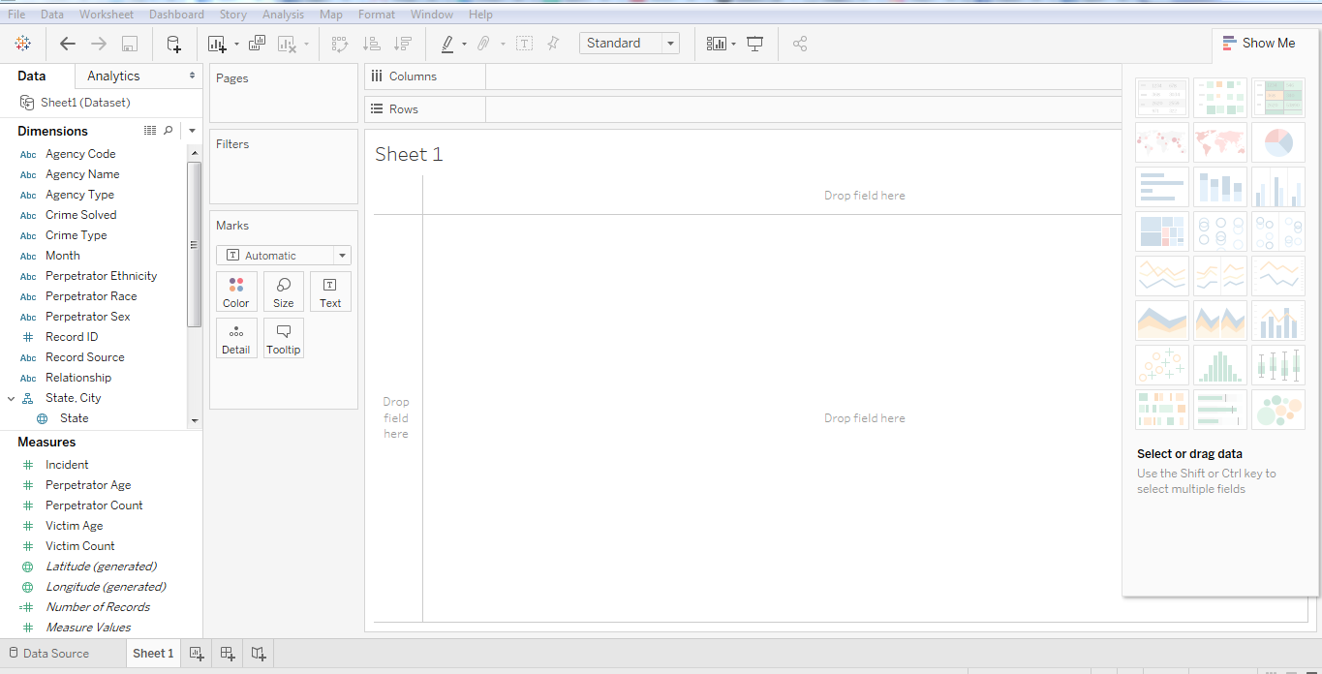

**UI- Show me the data**

This is the pane with which you can create visualizations. You can create different visualization in order to represent your dataset.  The diagram below shows the ‘show me’ data pane:

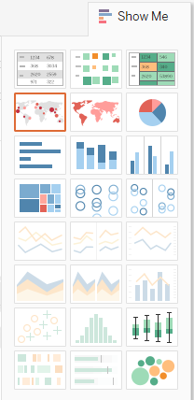

Some visualizations might not be available at times because of incompatible dataset.

Below are the most popular visualizations used widely in Tableau:

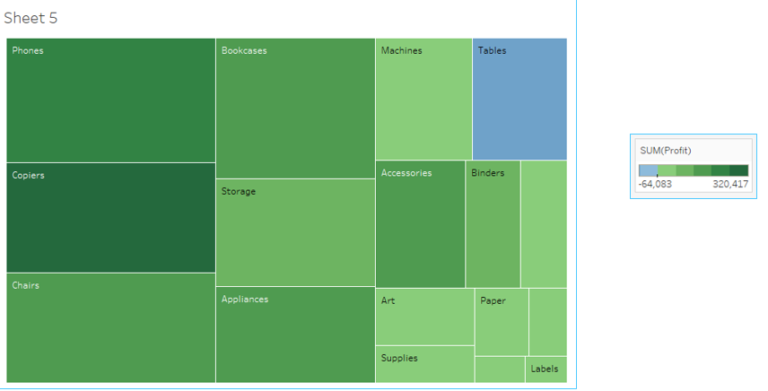

*Tree Map*

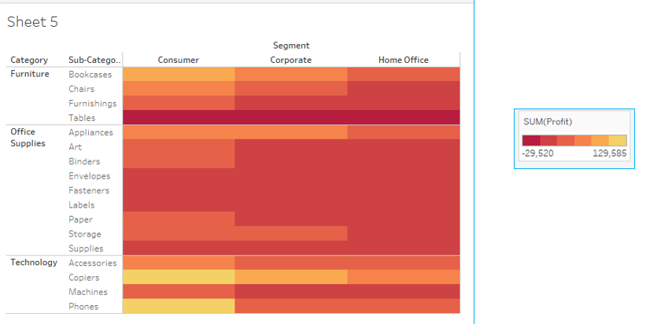

*Heat Map*

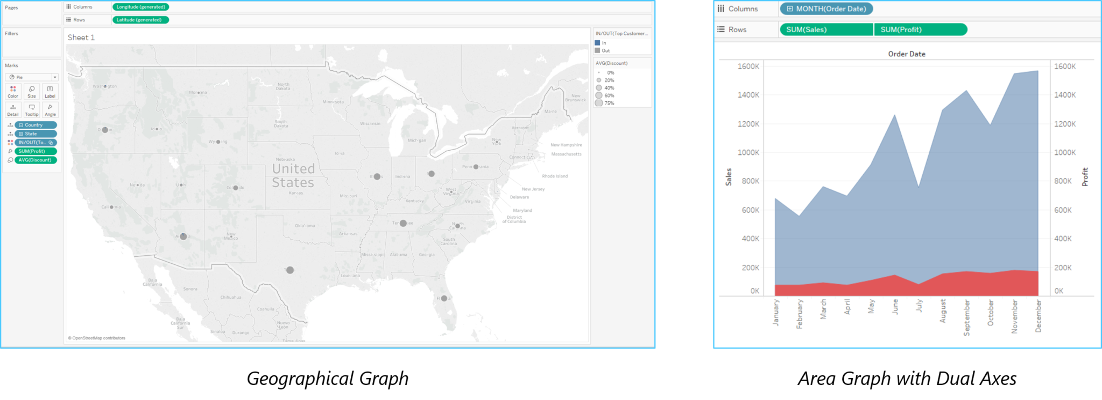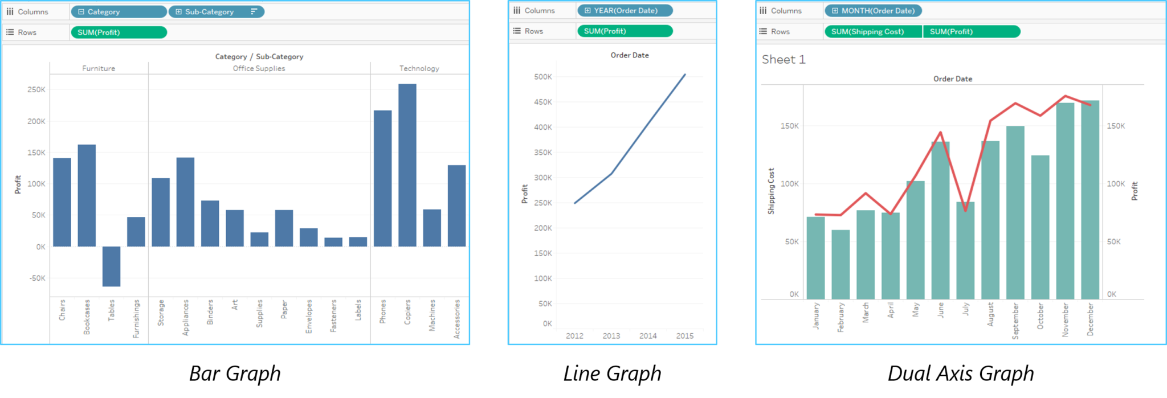Now let’s explore few more options available in our UI.

**Menu**

The menu bar in Tableau consists of various options to edit your visualization. Let me take you through them one by one.

**Menu Bar - Tableau Tutorial - EdurekaFile menu**

This Menu is used to create new Tableau workbook and open existing workbooks from both local system and Tableau server. The important features in this menu are:

* **Workbook Locale** to set the language to be used in the report.
* **Paste Sheets** to paste a sheet into the current workbook which is copied from another workbook.
* **Export Packaged Workbook option** is used to create a packaged workbook which will be shared with other users.

**Data Menu**

This Menu is used to create new data source to fetch the data for analysis and visualization. It also allows you to replace or upgrade existing data source.

The important features in this menu are as follows:

* **New Data Source** to see all the types of connections available and choose from it.
* **Refresh All Extracts** to refresh the data form source.
* **Edit Relationships option** is used to define the fields in more than one data source for linking.

**Worksheet menu**

This Menu is used to create new worksheet along with various display features like showing the title and captions etc.

The important features in this menu are as follows:

* **Show summary** to see the summary of the data used in the worksheet like count etc..
* **Tooltip** to show the tooltip when hovering above various data fields.
* **Run Update option** is used to update the worksheet data or filters used.

**Dashboard menu**

This Menu is used to create a new dashboard along with various display features like showing the title and exporting the image etc..

The important features in this menu are as follows:

* **Format** is used to set the layout in terms of colours and sections of the dashboard.
* **Actions** to link the dashboard sheets to external URLS or other sheets.
* **Export Image option** is used to export an image of the Dashboard.

**Story Menu**

This Menu is used to create a new story which has many sheets or dashboards with related data.

The important features in this menu are as follows:

* **Format** is used to set the layout in terms of colours and sections of the story.
* **Run Update** to update the story with latest data form source.
* **Export Image option** is used to export an image of the story.

**Analysis Menu**

This Menu is used for analyzing the data present in the sheet. Tableau provides many out of box features like calculating the percentage and doing a forecast etc..

The important features in this menu are as follows:

* **Forecast** to show a forecast based on available data.
* **Trend Lines** to show the trend line for s series of data.
* **Create calculated Field option** is used to create additional fields based on certain calculation on existing fields.

**Map Menu**

This Menu is used for building map views in Tableau. You can assign geographic roles to fields in your data.

The important features in this menu are as follows:

* **Map Layers** to hide and show map layers, such as street names and country borders, and add data layers.
* **Geocoding** to create new geographic roles and assign them to the geographic fields in your data.

**Format Menu**

This Menu is used for applying the various formatting options to enhance the look and feel of the dashboards created. It provides features like borders, colours, alignment of text etc..

The important features in this menu are as follows:

* **Borders** to apply borders to fields displayed in the report.
* **Title and caption** to assign a Title and caption to the reports.
* **Cell Size** to customize the size of the cells displaying the data.
* **Workbook Theme** to apply theme to the entire workbook.

**Server Menu**

Server Menu is used to login to the Tableau server if you have access and publish your results to be used by others. It is also used to access the workbooks published by others.

The important features in this menu are as follows:

* **Publish Workbook** to publish the workbook in the server to be used by others.
* **Publish Data source** to publish the source data used in the workbook.
* **Create User filters** to create filters on the worksheet to be applied by various users when the access the report.

**3. Create Visualizations**

Above in this Tableau tutorial, you have seen the different The following table tells you how to choose the right visualization for your dataset out of many available options.

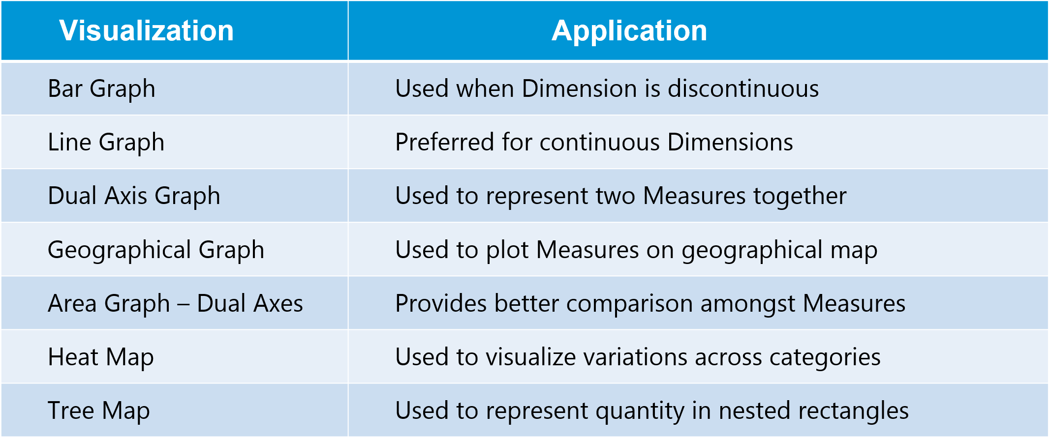

Now, let us have a look at a case study to understand how Tableau can help in solving real-life business problems.

**Tableau Use Case – Datamatics**

Datamatics is the subsidiary of world’s largest bank based on market capitalization, dealing in securities and stocks investments. It provides services in all major areas of investment like equity, IPO, derivatives, mutual funds, insurance etc.

**Business need:**

Being a part of an extremely dynamic industry, tracking the slightest market development is of highest priority for the client. They needed a solution that could enable them to react quickly to the varying market trends. A solution that would be able to generate hassle-free, ad-hoc & secured reports that could provide accurate data visualization.

**Challenges:**

Unable to react quickly to market developments and regulatory requirements The existing system had a high turnaround time which delayed the overall decision making process.

Restricted and inflexible data visualization reports resulted in poor interpretation of data The system compromised on security aspects and had high IT support dependency Lack of effective versatility to do ad-hoc analyses from multiple viewpoints.

**Solution:**

Datamatics selected Tableau, a leading Data Visualization BI tool in the market. As per requirements gathered, various Dashboards and Reports were designed for various levels. Refer to the diagram below to understand how Datamatics made use of Tableau:

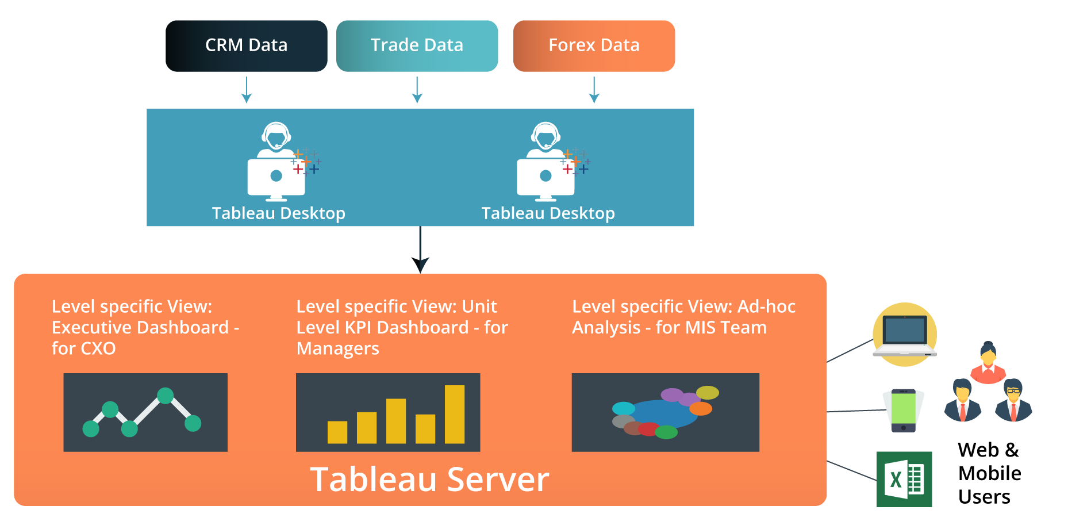

Tableau was connected with the existing data bases of the organization. Unique and relevant visual dashboards & reports were developed for people at different levels across the organization as well as to cater the day-to-day needs of different departments.

**Results:**

* Time taken to generate analytical reports/MIS reduced to 1-2days with zero loss of data.
* Efficient integration of excel and other flat files based data with structured data to create deep & versatile analytical insights.
* Easy and optimized data visualization options to slice & dice the reports for more meaningful and comprehensive viewing.
* Enhanced security features with role based access.
* Maximum level of ease to distribute & share the reports even amongst extended team members.
* Dependency on the IT team or external vendors for report generation was minimized.
* Easy installation and integration of the solution with the existing system reduced.
* Total Cost of Ownership for the client Boosted the identification of cross-selling and up-selling opportunities.